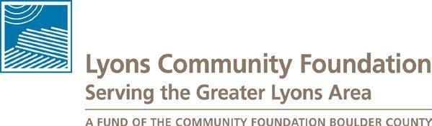
Lyons Community Foundation
PO Box 546
Lyons CO 80540
720-29-LYONS
www.LyonsCF.org

2023 Grants Review Committee Application

Thank you for your interest in serving on the Grant Review Committee for the Lyons Community Foundation (LCF). The mission of LCF is to improve the quality of life, build a culture of giving and encourage positive change for the Greater Lyons Area. The purpose of the Grant Review Committee will be to review the grant applications and make recommendations to the Advisory Board for grant awards. LCF is generally interested in a broad range of projects from a variety of eligible organizations.

Please submit your application, via email to: grants@lyonscf.org by September 4, 2023. Fill out this application, save to your computer, and submit as an attachment to your email. Please submit the attachment as a Microsoft WORD (.doc) or PDF (.pdf) document.

A confirmation that your application was received will be sent to you. Please submit questions well in advance of the September 4, 2023 due date to Ella Levy, Chair of the LCF Grants Committee, at grants@lyonscf.org.

A. General Information

Name of Applicant:

Mailing Address: Phone:
Email:

B. Information Regarding the Grant Review Committee

Committee member eligibility: Lyons area resident (not limited to just Town residents); and you are not planning to submit a grant application, or you are not involved with an organization that is applying for funds (although persons involved with a grant applicant can still be a member of the Committee, assuming that the person will recuse her/himself from discussions on that application).
Committee member responsibilities: 1) be familiar with the LCF Grant Guidelines and Application Format, including the review criteria for scoring the applications, found on the LCF webpage; 2) attend 2 meetings; 3) read and score each grant application on the merit of the application; 4) participate in discussions about each application; 5) sign a conflict of interest statement; and 6) sign a confidentiality statement.

Committee discussions, including the Committee membership, are confidential and will not be released to the public (including grant applicants).

Schedule and Committee meetings: the following is the tentative schedule for the grants process.

Date | Event/Task
Sept 18  6:00-7:00 pm | First meeting of Grants Review Committee; orientation & information on  reviewing grant applications; distribution of grant applications
Sept. 18 – Sept.  26 | Review grant applications on your own  completed score sheets due by Sept. 26
Sept. 29  6:00-9:00 pm | Final meeting of Grants Review Committee to determine grants awards recommendations.

Please check your availability for the meetings before you apply to serve on this committee.

C. Application qualification questions
Please answer the following questions as completely as possible.

1. What is your connection to the greater Lyons area?

2. What are your interests for serving on the grant review committee?

3. Please describe any previous experience you have had with a granting process, as an applicant or a reviewer.

Signature of Applicant Date

Thank you for your application and support of the Lyons Community Foundation

